pUML

phunctional UML editor

<< pow >>

|  |
| --- |
| **pUML User Manual** |

Contents

What is pUML? 3

Installation Instructions 4

Introduction to the pUML main window. 5

Create a New Diagram 6

Editing Your Diagram 8

Help / FAQ 9

# What is pUML?

pUML is a fantastic UML diagram drawing software developed by a team of seven geniuses, currently students at the University of Idaho. This software was developed for a school project, and is by no means considered to be complete, useful, or phunctional at time of this user manual publication.

# Installation Instructions

Carefully follow the installation instructions to ensure pUML is successfully installed on your computer.

1. Double-click the pUML icon on your desktop.
2. Follow the steps indicated by the installation wizard.
3. If you need help at this point, you probably don’t have any use for this software.

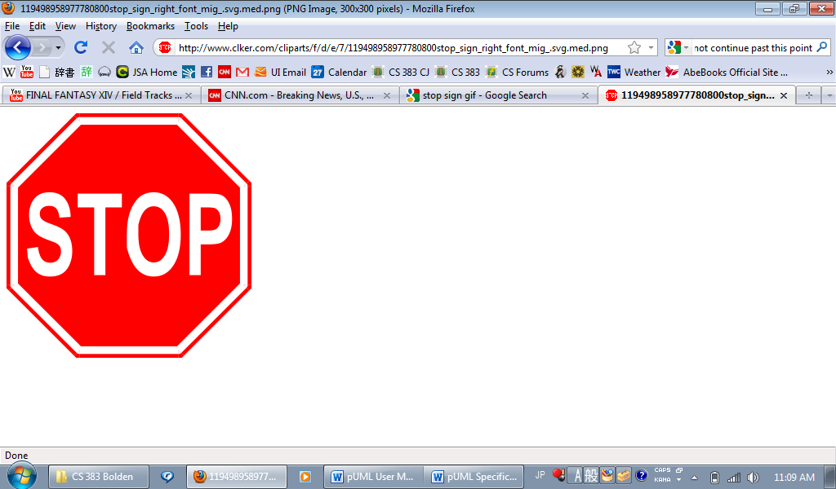

# Introduction to the pUML main window.

# Create a New Diagram

1. On the pUML main window toolbar, click “File.”
2. Click “New Diagram”
3. Highlight your desired diagram type from the list presented, and click “OK.”

The shapes for your diagram type will appear in the toolbar to the left of the drawing canvas.

**To place shapes on the canvas:**

1. Click on the desired shape in the toolbar.
2. Click on the canvas to place the selected shape at that location.
3. Right click on any object to add a title or description.

**How to place connectors:**

To place connectors, you must have at least two shapes already on the canvas. To connect the shapes:

1. Click on the desired connector in the toolbar.
2. Click down on the originating object on the canvas and holding the left mouse button down, drag the mouse to the object you’d like to connect to. This will place a connector between the two objects.
3. Right click on the connector to add a description.

***Note:*** *some connectors have specific descriptions which may not be modified.*

# Editing Your Diagram

Renaming an object or a connector:

Right click on the object to change the title or description.

Deleting an object:

Right click on the object and select delete.

or,

Click on the object and press the “Del” key on your keyboard.

The object and any associated description will disappear.

***Warning:*** *When an object is deleted, any associated connectors will be deleted as well. Delete objects with care!*

Deleting a connector:

Right click on the connector and select delete.

or,

Click on the connector and press the “Del” key on your keyboard.

The connector and any associated title or description will be deleted.

***Note:*** *Deleting a connector will not delete any associated objects.*

# Help / FAQ

**HELP**

Life’s tough, isn’t it? And on a related note, this program is unsupported at this time.

**FAQ**

Q: How do I delete a pUML UML diagram?

A: Find the diagram on your computer and delete it the same way you would delete any other file on your computer.

Q: I want to embed a picture in my diagram that originates outside pUML.

A: That feature is not supported in pUML.

